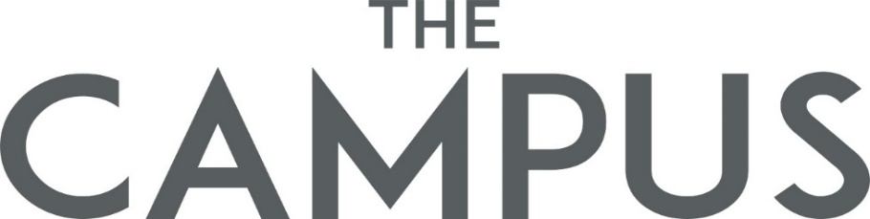

Route change form
Form – T 2
New Ferry Way

Start Date: End Date:

Current Ferry Way
Temporary Route Change
New Address

Start Date:
Current Address & Ferry Way
Permanent Route Change
Requested On
Department
Name

Remark
Please send the form to Admin Department.

